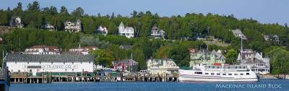

July 22-24, 2016

Two nights stay at Lake View Hotel http://www.lake-view-hotel.com/

Round trip ferry transportation from Mackinaw City on Schepler’s Ferry

Continental breakfast Saturday and Sunday morning

Cost for members At Signup May 17 June 21

1/room=$546 per person $80.00 $233.00 $233.00

2/room=$286 per person $80.00 $103.00 $103.00

3/room=$200 per person $50.00 $75.00 $75.00

4/room=$156 per person $50.00 $53.00 $53.00

Non-Member: $582 single, $322 double, $230 triple, $180 quad

Group Activities

Friday: 8:00 pm Dinner Get Together Gate House Restaurant

Saturday 10:00 am Bike ride around the Island; meet in front of Lake View ready to ride

5:00 pm Mixer and Photo Opportunity Meet behind the public library

Bring snacks or drinks to share

Trip Chairs:

Joanne Creede Tom Sarra

[kayjoe@comcast.net](mailto:kayjoe@comcast.net) or 517-285-4795 [tsarra@rescuemhs.com](mailto:tsarra@rescuemhs.com) or 563-271-3763

Cancellation date June 21, 2016. No refunds after June 21.