Kayak Outing
Sunday, August 2
Meet a 1 p.m. Depart 1:30 p.m.
AT
River Town Adventures Kayak and Canoe Rental
On the Grand River behind the City Market
Website: www.rivertownadventures.com.

A reservation for 10 kayaks with transport has been made for August 2, under Jug & Mug & Sharon Roberts. With the group rentals, they will transport your kayak for $5. Participants will pay all fees to River Town Adventures on the day of the event. If you bring your own kayak, unload behind the City Market between the Market and River Town sales tents. Everyone will meet and end at River Town Adventures if you are using their transport.

Meet at 1 p.m. to fill out paperwork and submit payment.

NOTE: Because weekends have a high request for equipment in the afternoons, you need to let Sharon (sharonann48@hotmail.com) know your intent of renting before August 2. If you do not sign up, you may have to wait for available equipment for a later departure time.

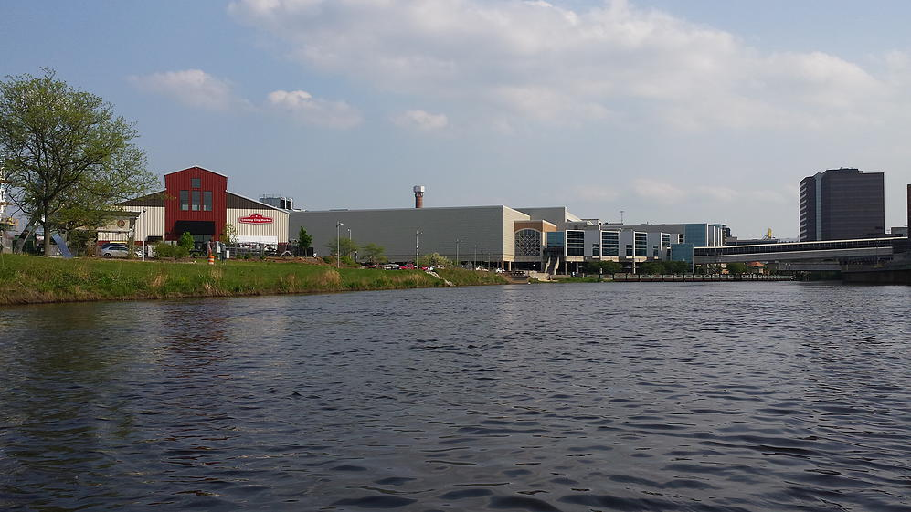
Two Trip Options: One Will Be Chosen
1- 1.5 Hour Adventure: Meet us at the City Market and we will shuttle you up stream to Moores Park.
$15 – Kayak
$25 – Canoe/ tandem kayak

ZOO TO THE MARKET – Kruger Landing Downstream to the City Market
2-2.5 Hour Adventure: Meet us at the City Market and we will shuttle you up stream to Kruger Landing.
$20 – Kayak
$35 – Canoe/ tandem kayak

Following the kayak adventure, we will congregate on the patio of the Waterfront Bar and Grill.

IMPORTANT: If you are interested in going, contact Sharon Roberts at sharonann48@hotmail.com before August 2. Let her know if you plan to rent or if you are bringing your own and want River Town to transport. Assisting Sharon are Bobbie Black, bbtweeter@yahoo.com and Rich Rybicki, richrybick@yahoo.com.

